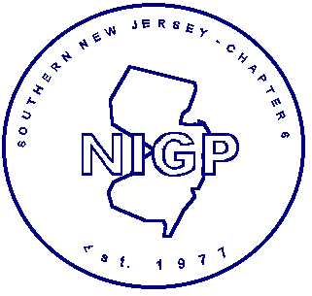  SOUTHERN NEW JERSEY  CHAPTER 6  of the  NATIONAL INSTITUTE OF GOVERNMENTAL PURCHASING  This is to certify attendance at the  Regular Meeting  February 22, 2006  1 Credit Hour  good towards  RPPS, RPPO, CPPB and/or CPPO Recertification |  | SOUTHERN NEW JERSEY  CHAPTER 6  of the  NATIONAL INSTITUTE OF  GOVERNMENTAL PURCHASING  This is to certify attendance at the  Regular Meeting  February 22, 2006  1 Credit Hour  good towards  RPPS, RPPO, CPPB and/or CPPO Recertification

